Bongongo Public School - 1293

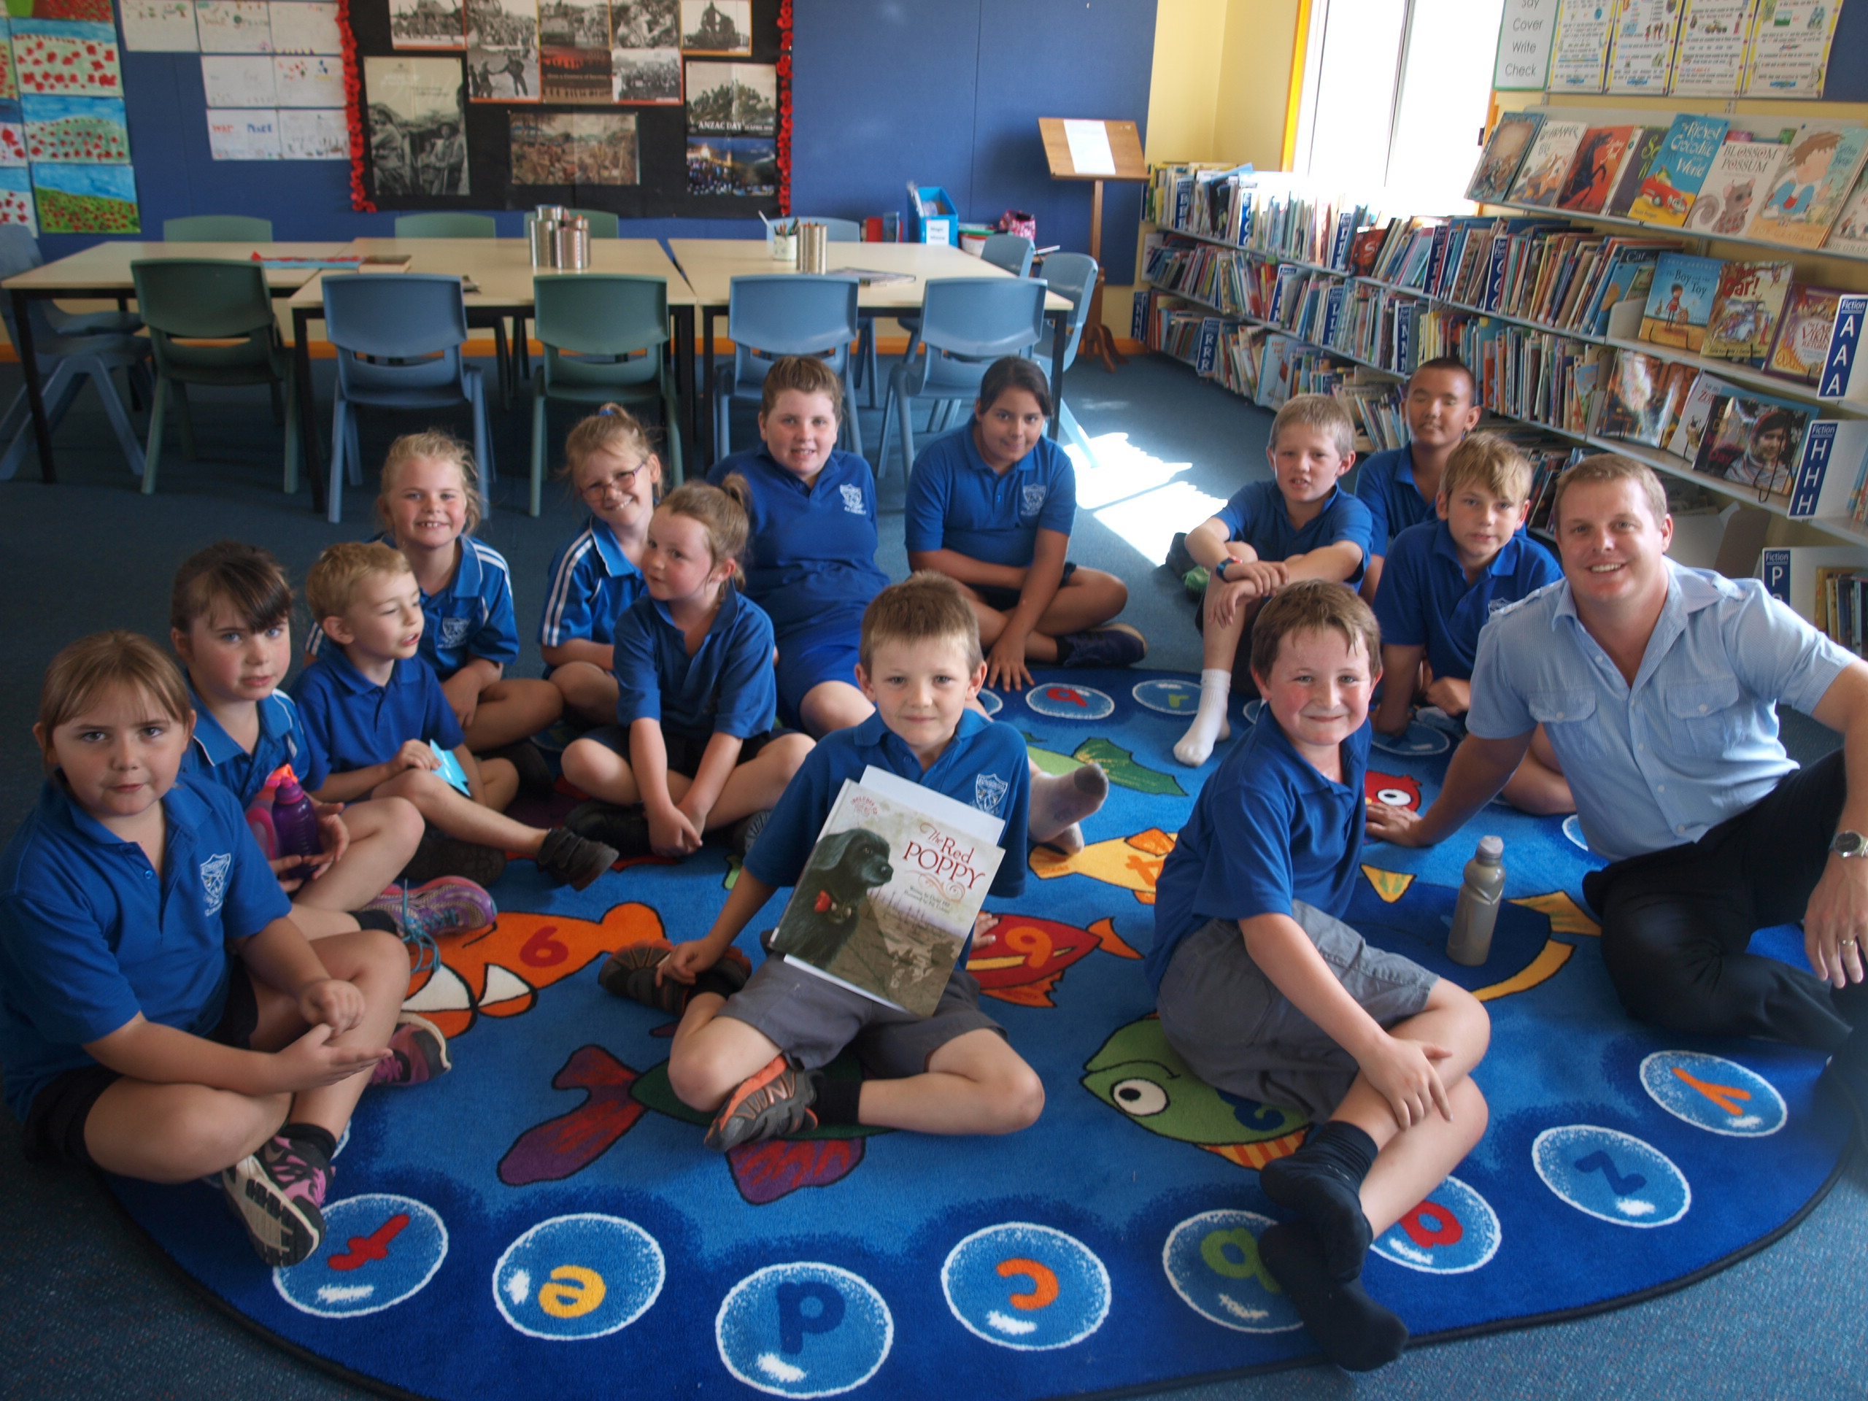

School vision statement |  | School context |  | School planning process
At Bongongo Public School we will empower learners by working in partnership within and beyond our school in a strategic, enthusiastic and purposeful way. We will inspire the development of confident, creative, resilient and innovative individuals, fostering an environment of critical thinkers and problem solvers who are engaged and resourceful learners. |  | Bongongo Public School nestles in the hills of Adjungbilly. It is a small isolated school on the north-western edge of the Snowy Mountains in southern NSW. Staff, students and community work collaboratively to create a happy learning environment where quality education is assured. The school provides a happy, caring and supportive environment where all students are encouraged to strive for excellence in all facets of school life. The needs of each individual student are addressed through the provision of relevant, quality educational programs supported by active parent involvement. The school is the focal point of the community and the students are provided with a wide variety of opportunities for learning both within and outside the local area. |  | The school undertook an extensive planning process to inform the strategic directions for the next three year school plan. This process assisted the school in identifying its strengths and areas of need, the key aspects impacting student learning and determining priorities for future planning. As part of the planning process;  • Staff were provided with professional learning sessions on the research behind the new planning tool and identifying the purpose of the plan.  • Teaching staff took part in professional learning around the new tool and the processes in developing the new school plan.  • Data was analysed and an in-depth SWOT Analysis was completed and discussed with all staff. From this the three strategic goals were identified and discussed with the community.  • Staff and parents worked collaboratively to develop the 5P approach across all strategic directions. The draft plan was shared with all staff and parents to ensure collective understanding and efficacy.  • The staff worked together to develop the Milestones section of the plan

STRATEGIC DIRECTION 1  Empowering excellence in Learning |  | STRATEGIC DIRECTION 2  Empowering Learners of today for tomorrow |  | STRATEGIC DIRECTION 3  Community Engagement
Purpose:  To enhance leadership and teaching practices through 21st century pedagogy and targeted professional learning.  Creating a professional environment that is aligned with the Australian Professional Teaching Standards, where teachers engage professionally and collaboratively to deliver 21st Century learning. |  | Purpose:  To improve all KLA standards through high quality teaching, innovative 21st century practices, personalised learning and explicit high expectations.  A culture of success and the development of relevant and engaging curriculum for 21st century learning. |  | Purpose:  To build collaborative and collective ownership of student learning in order to build student aspirations.

Strategic Direction 1: Empowering excellence in Learning

Purpose |  | People |  | Processes |  | Products and Practices
Why do we need this particular strategic direction and why is it important?  To enhance leadership and teaching practices through 21st century pedagogy and targeted professional learning.  Creating a professional environment that is aligned with the Australian Professional Teaching Standards, where teachers engage professionally and collaboratively to deliver 21st Century learning. |  | How do we develop the capabilities of our people to bring about transformation?  Students: Engage and apply 21st Century learning tools to enhance learning outcomes.  Staff: Support students by providing challenging and stimulating learning experiences and opportunities. Staff will implement creative practice and demonstrate evidence of personal skill development and the use of ICT tools and online environments.  Parents/Carers: To support the collaborative learning community by working together with teachers and students to foster an environment which facilitates 21st Century learning.  Community Partners: Instil the attitudes and values that will support the school community to provide a dynamic education that reflects 21st Century skills and understanding.  Leaders: Provide continuing strategic direction about the impact of 21st Century practice on the development of creative, innovative and resourceful learners. |  | How do we do it and how will we know?  - P/L sessions to support and enhance staff knowledge and understanding of 21st Century Learning practices, with a focus on technology  - Staff trained in ICT, show and share sessions if no professional learning opportunities are available  - Reflective practice by staff as self and collaborative activity  Evaluation Plan  Teacher Performance and Development Framework Annual review and self-assessment along with PL meeting notes demonstrate teacher reflection and implementation of current research and practices. |  | What is achieved and how do we measure?  - 100% of teachers demonstrate evidenced professional growth against the Australian National Teaching Standards.  - All teachers will evaluate and reflect on current research and practice in the use of existing and emerging 21st Century teaching tools and strategies to support student learning as shown in PL meetings.  Product:  - Professional learning will evaluate and reflect on current research and practice in the use of existing and emerging 21st Century teaching tools and strategies to support student learning.  Product:  - Teaching programs and practices demonstrate an understanding of pedagogical practices required by 21st Century learners.  What are our newly embedded practices and how are they integrated and in sync with our purpose?  Practice:  - Teaching programs and practices demonstrate explicit integration of ICT, digital citizenship and innovative practice.  Practice:  - Teaching strategies will engage learners, promote higher order thinking and facilitate creative learners.
Improvement Measures
- 100% of teachers demonstrate evidenced professional growth against the Australian National Teaching Standards.

- All teachers will evaluate and reflect on current research and practice in the use of existing and emerging 21st Century teaching tools and strategies to support student learning as shown in PL meetings.

Strategic Direction 2: Empowering Learners of today for tomorrow

Purpose |  | People |  | Processes |  | Products and Practices
Why do we need this particular strategic direction and why is it important?  To improve all KLA standards through high quality teaching, innovative 21st century practices, personalised learning and explicit high expectations.  A culture of success and the development of relevant and engaging curriculum for 21st century learning. |  | How do we develop the capabilities of our people to bring about transformation?  Students: To engage students in being successful quality learners of literacy and numeracy.  Staff: To develop staff capabilities by designing training and school-wide systems and structures to allow students to reach their full potential.  Parents/Carers: To support the collaborative learning community by working together with teachers and students to improve the intellectual quality of programs in the school.  Community Partners: Opportunities to inform and develop community knowledge and understanding of school programs, curriculum expectations and 21st Century practice will be made available.  Leaders: To have advanced knowledge and understanding in current pedagogical practice and research to support relevant and practical learning in literacy and numeracy. |  | How do we do it and how will we know?  - P/L based on how to create quality programs that utilise data from school and external assessment  - Utilise quality programs and effective teaching strategies to engage students through explicit instruction and active learning  - Use innovative practices to embed higher-order thinking skills to foster creative learners.  Evaluation Plan  Termly monitoring of school based assessment, progress on the continuums, benchmark data, L3 data and analysis of NAPLAN results to track student progress in Literacy and Numeracy. |  | What is achieved and how do we measure?  - All students at or above grade expectations in aspects of Literary and Numeracy according to continuums and school based data ( including ACER testing, Reading levels)  - To sustain student growth in NAPLAN by over 60% between years 3 and 5.  Product:  - Deep knowledge and deep understanding will promote sustained literacy and numeracy growth, which will be demonstrated across all in school and external standardised assessments  Product:  - Students will have essential skills in literacy and numeracy and are creative and productive users of technology, especially ICT, as a foundation for success in all learning areas.  What are our newly embedded practices and how are they integrated and in sync with our purpose?  Practice:  - Students and staff reflect on and regulate their learning, adjusting learning to achieve their personalised learning and leadership goals.  Practice:  - Quality teaching and learning practices across the school demonstrated through differentiated literacy and numeracy lessons and formative and summative learning assessment to improve student achievement.
Improvement Measures
- Improved NAPLAN performance in Literacy and Numeracy with greater percentage of students in top two bands across all areas.
- All students at or above grade expectations in aspects of Literary and Numeracy according to continuums and school based data ( including ACER testing, Reading levels)
- To sustain student growth in NAPLAN by over 60% between years 3 and 5.

Strategic Direction 3: Community Engagement

Purpose |  | People |  | Processes |  | Products and Practices
Why do we need this particular strategic direction and why is it important?  To build collaborative and collective ownership of student learning in order to build student aspirations. |  | How do we develop the capabilities of our people to bring about transformation?  Students: Provide students leadership development to help give them a voice to their learning  Staff: Support a shared understanding of personal and collective efficacy, ensuring teaching and non-teaching staff has an alignment to the school plan and vision.  Parents/Carers: Value excellence in education and support school initiatives to engage students in learning to reach or exceed attainment levels in all areas.  Community Partners: Establish proactive learning and wellbeing alliances with other schools and community members to the delivery of educational innovation projects.  Leaders: Engaging external agencies and developing bonds to enhance the learning and wellbeing of all students. |  | How do we do it and how will we know?  - Greater student participation and involvement in all learning activities that have been facilitated through joint partnerships between the school and the whole community.  - Create two-way communication processes that support active, frequent and culturally sensitive collaboration between school and community  - Build proactive active learning alliances to promote successful relationships with Tumut Schools, the Small Schools Network, local high schools and preschools.  Evaluation Plan  Review the effectiveness of our partnerships and programs. |  | What is achieved and how do we measure?  Increase in positive comments through parent feedback showing the success of the school’s assessment and reporting process K-6.  - Surveys reflect high satisfaction amongst teachers, parents and students in achievement of educational outcomes and provision of quality learning environment.  Product:  - A supportive school community evidenced by sharing students’ learning, community events, fundraisers, and increased number of parents attending school events.  Product:  - Improvement in parent collaboration and participation in school-family partnerships.  What are our newly embedded practices and how are they integrated and in sync with our purpose?  Practice:  - Three-way, reciprocated and respectful communication between students, staff and parents most  Practice:  - A strong and sustained positive culture of learning across students, staff, parents and the wider community
Improvement Measures
- Surveys reflect high satisfaction amongst teachers, parents and students in achievement of educational outcomes and provision of quality learning environment.
- Increase in positive comments through parent feedback showing the success of the school’s assessment and reporting process K-6.

